Kip Taylor

Database

Last hw

1. Answer below.

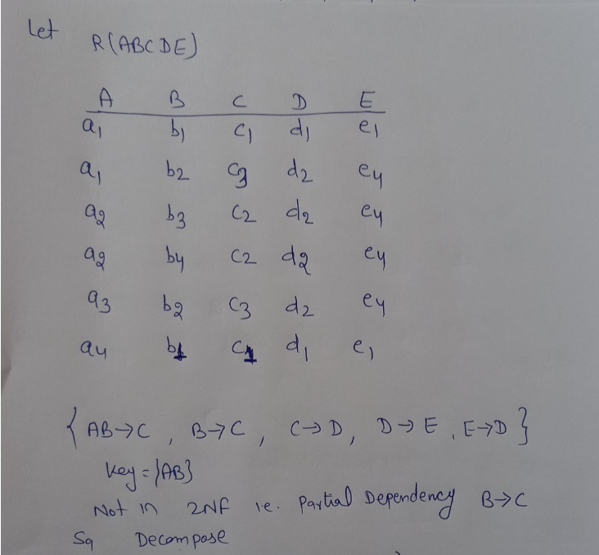

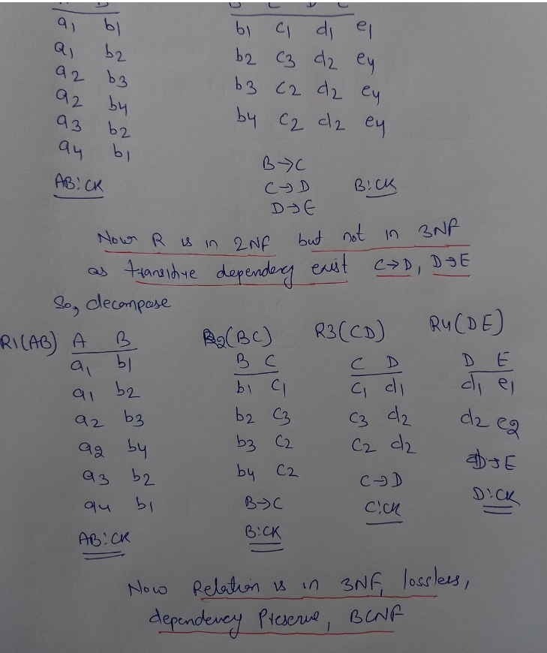

Hope this covers what was asked. If you need any more let me know please.

1. Answer below.
2. SQL Injection are common for below reasons  
    Prevalence of SQL Injection vulnerabilities  
    As database contains critical information

SQL injection attack is a attack that send malicious commands to database to retrieve sensitive data.

We can prevent this by:  
1. By encrypting sensitive data  
2. Giving accounts to users with least privileges necessary.  
3. Ensure that data is valid.  
4. Use stored procedures.  
5. Use a firewall  
6. Apply regular software patches.  
7. Monitor SQL statements continuously.

1. Answers below

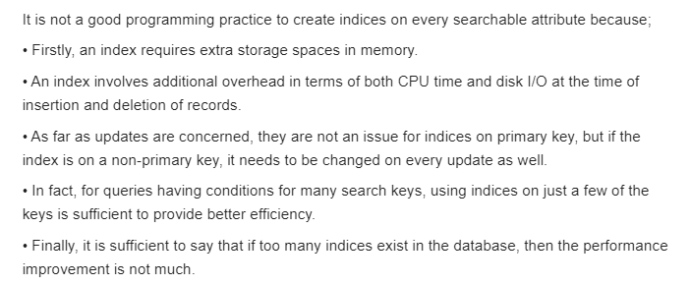

1. Answer below.

Attempted to optimize the initial version we can modify a little bit. We can perform the join operation first and then select. the city as Kent. This method will help reduce redundancy in our relational algebra query

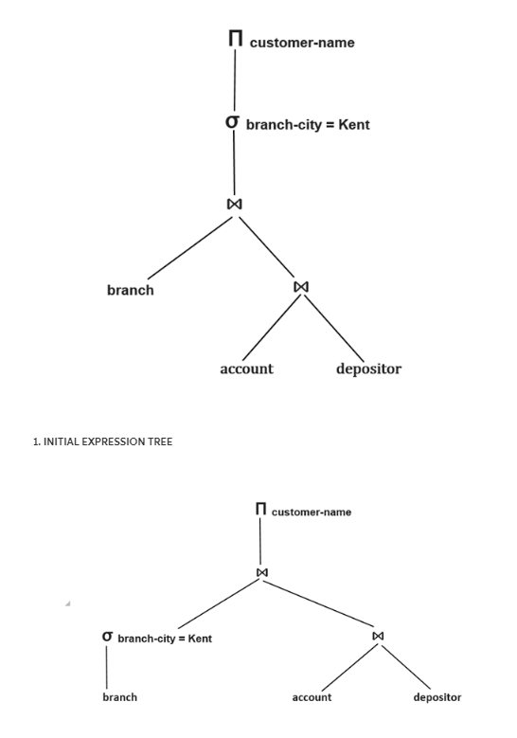

1. ACID stands for, Atomicity, Consistency, Isolation, Durability.
2. Atomicity: It states that a database transaction must contain everything or nothing. It requires complex ways to be achieved. If a transaction has various steps, all steps must occur simultaneously.
3. Consistency: It states that data cannot be changed without following database rules. If a transaction occurs in violation, error occurs and roll back happens.
4. Isolation: It states condition of database management to ensure levels of maintaining data isolation from various simultaneous operations, so that lock condition doesn't occur, and deadlock doesn't happen.
5. Durability: Ensures permanent data saving so that during a database crash, data can be easily recovered during recovery. Storage happens on a secondary memory storage. It completes reliability of the ACID system.
6. A transaction is the lowest entity in a database which must follow ACID properties, carries out data retrieval or update.
7. A lock occurs when a process locks data it is working on in anticipation of another process accessing that data.
8. A deadlock occurs when a process 1 locks data and blocks process 2 and process 2 blocks data it is using and process 1 is made to wait. All this happens simultaneously.

That should cover all types with scenarios in simplification.